**Enable the Developer Tab:**

**File->Options**

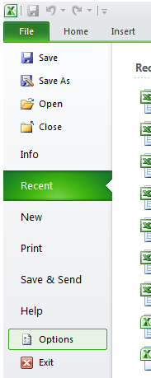

Click on **Customize Ribbon:**

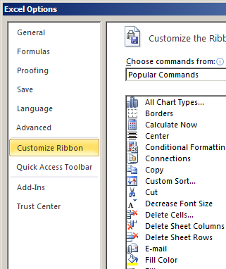

Check the **Developer** box and push **OK**:

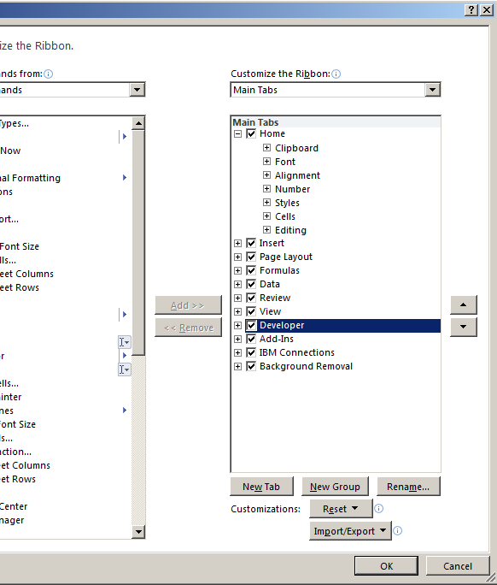

**Run the Script:**

Click the **Developer** tab and then click on **Visual Basic:**

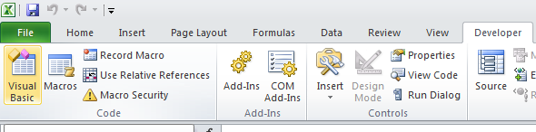

In the Visual Basic screen, click **File** then **Import File…**:

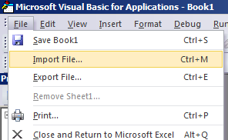

Choose the appropriate script, then close the **Visual Basic** window:

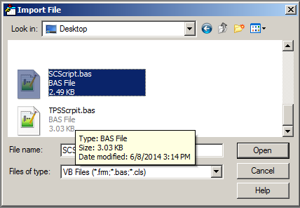

In the Excel file, click the **View** tab then click the **Macros** button:

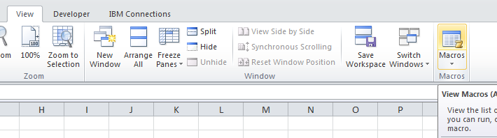

Choose the appropriate script and click **Run**:

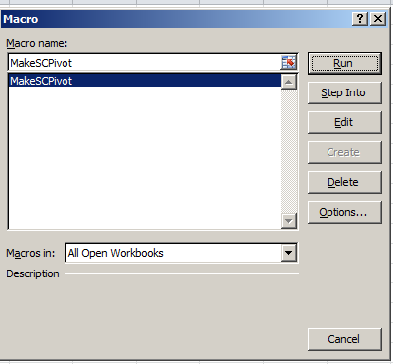

End of tutorial